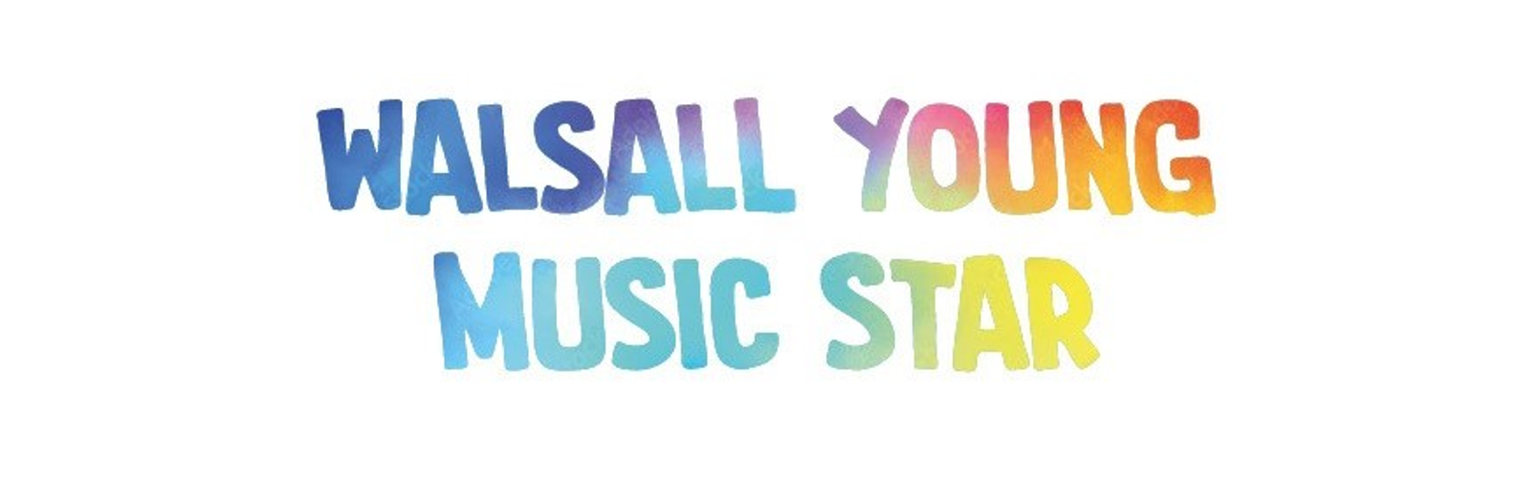
WYMS Entry Form 2026
Please email your completed form to Matt Firkins (matt.firkins@walsall.gov.uk)
Heats Information: Heats are to be performed live where possible. These will be held W/C 2rd March, likely to be in the evening from 4:30pm onwards on Wednesday 4th March (Tuesday 3rd March evening as well, if needed). However, if these dates cannot be met, please email Matt to discuss a way forward.
Application and consent form: to be completed by parent/carer
Category:
WYMS or Up and Coming
Entrant’s Name

Age

School

Instrument

Name of usual instrument/singing teacher

Parent/Carer Name

Parent/Carer email (for use during this competition)

Parent/Carer mobile (for use during this competition)
DECLARATION: By dating and signing, you accept the conditions as laid out in the safeguarding statement and submission rules (see website https://www.walmused.co.uk/wyms/rules-and-regs/)
SIGNATURE: Your digital signature (typed name) confirms you act on behalf of the applicant
Date

Please email your completed form to Matt at matt.firkins@walsall.gov.uk

