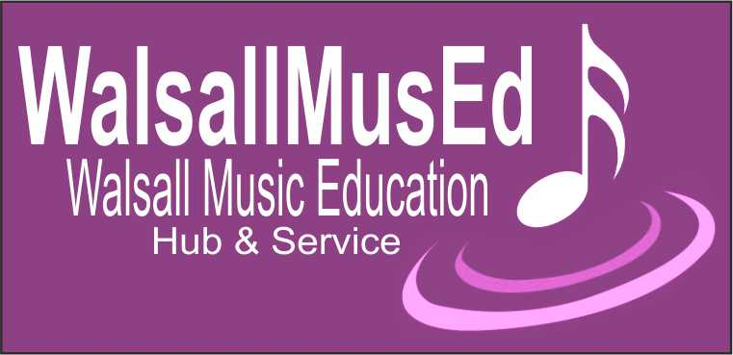

Summer Singing Festival
24th - 28th June 2024

Walsall Music Hub will be holding a week-long Summer Singing Festival in June for Infant, Junior and Secondary Schools.

The festival will take place in Auditorium One at the Walsall Arena and Arts Centre. The day starts at 09:15 and finishes at 14:45 (half a day for Infants – see booking form).

As discussed in the MusE and Mini MusE network meetings:
- Junior and Infant schools are invited to showcase and share two or three songs of your choice. Your program must not exceed 8 minutes in total. A workshop with new material will then follow.
- Secondary schools are not showcasing material, all your material will be from scratch and delivered through a workshop on the day.

For all schools the day will be run by Rock Choir Rock Stars – the student version of the adult choir you may know as “Rock Choir”. You can find more information and video links on our website.
The event will culminate in a short informal sharing performance for parents to come along to and enjoy. Numbers are limited and subject to availability.

Application details:
Entry to the Singing Festival requires a booking form and payment for the relevant school: infant, junior or secondary. The infant festival lasts for half a day, the junior and secondary a whole day.

For Infant and Junior days, equipment will be available for backing tracks or a piano will be available for your own accompanist, or you can use our resident accompanist if scores are sent in advance. Backing tracks and scores are to be sent to: glen.taylor@walsall.gov.uk

Application forms need to be returned by FRIDAY 22nd MARCH 2024.

Please note schools will be allocated places on a ‘first come, first served’ basis. Schools will be notified by email once they are allocated a date with further details of the day.

This is a sharing of school singing and a non-competitive event. We would encourage as many of you to take part as possible and all schools will be presented with a Certificate of Participation.

The sharing performance audience numbers are limited and subject to availability.

Summer Singing Festival 2024 BOOKING FORM

Name of School
Name of Lead Teacher
Email for Lead Teacher
Phone number

Year Group/s |  | Number of students |  | Number of accompanying adults

Details of any disabilities

SELECT WHICH FESTIVAL YOU ARE APPLYING FOR BELOW

Infant Singing Festival |  |  |  | Indicate 1st choice with a 1 and 2nd choice with a 2
Mon 24th June 12:00 – 14:45 |  |  |  | Fri 28th June 9:15 – 12:00

Junior Singing Festival |  |  |  | Indicate 1st choice with a 1 and 2nd choice with a 2
Tues 25th June 9:15 – 14:45 |  |  |  | Weds 26th June 9:15 – 14:45

Secondary Singing Festival on Thursday 27th June 9:15 – 14:45

(please tick if you’re coming to this one) PTO

To secure your place you must either pay by card over the phone to our Music Administrator, Lizzie Sale, OR complete this form with a purchase order number so we can invoice your school.
Your booking cannot be confirmed without one of these options.
Please tick or fill out one of the following boxes:

INFANTS:

I have paid £45 by card to Lizzie Sale on 01922 652623 (please tick)

I request an invoice and my purchase order number for £45 is:

JUNIORS:

I have paid £65 by card to Lizzie Sale on 01922 652623 (please tick)

I request an invoice and my purchase order number for £65 is:

SECONDARIES:

I have paid £85 by card to Lizzie Sale on 01922 652623 (please tick)

I request an invoice and my purchase order number for £85 is:

By signing this form, you confirm that (please tick):

You understand that this event is taking place in a public building. As such it is not possible to prohibit filming or photographs to be taken by members of the public, or where taken and requested for personal use, it is not possible to control where such footage might then be shared or uploaded to.

You also understand that photographs and videos may be taken by Walsall Music Education Hub and Service (WMEHS) and it is your responsibility to gain parental permission for pupils to be photographed or filmed.

The parents/guardians of the children involved understand that photographs or recordings may be used on the WMEHS YouTube channel and website, and possibly also on other WMEHS social media platforms such as Twitter, Facebook and Instagram.

You understand that should any footage be used by WMEHS, once any footage is online, WMEHS cannot

prevent unauthorised downloading.

In the rare circumstance that a pupil may not be able to be filmed or photographed but wish to take part, this information must be shared with WMEHS prior to the event and for WMEHS to have given written understanding that they have received this information. In this case, the lead teacher must then work with WMEHS to mitigate occurrences of filming and photographing happening with that pupil and be mindful of the top paragraph of this declaration. The lead teacher also then agrees, if needed, to respond swiftly to photographs or films that may be used to ‘finalise’ that footage before uploading or publicising.
Y

Should any school ask for retrospective withdrawal or amendment of photos or other media footage an administrative fee may apply, the amount of which will vary in accordance with the nature of the request.
Date:
Signature:

Name:

Job Role:

PLEASE RETURN TO LIZZIE SALE, Music Administrator, at Elizabeth.Sale@walsall.gov.uk

